January 2020

Open Call for Young Innovators
for
the DANUBE ENERGY+ TOOL

Open Call for Young Innovators
for
the DANUBE ENERGY+ TOOL

Background
Danube Energy+ tackles the need for change in regional ecosystems to support Young Innovators in transforming their disruptive ideas into ventures. Project´s general objective is to create an enabling environment, which will support Young innovators to pioneer a change in the energy efficiency area by setting up innovative startups in the Danube macro-region.
The learning system will be piloted in 9 countries involving 90 key regional ecosystem actors and 90 Young innovators enabling improvement of regional ecosystem actors´ knowledge.
What do we offer?

DANUBE ENERGY+ TOOL (program) is developed to provide a tool for boosting Young Innovators (YIs) towards starting successful ventures. It is a pre-seed / pre-acceleration learning scheme targeting YIs and their research projects with an innovation and commercial potential contributing to the sustainable energy challenge, with specific industrial focus on innovative solutions addressing energy efficiency field that are still at the idea stage, but with no product, traction, or even a working prototype.

Program content
Learning structure is based on 40 hours of education which include this topics:
(1) specifics of business in energy efficiency,
(2) current networks, challenges and opportunities in the field
(3) competition analysis and advantage,
(4) customer/market validation,
(5) business skills including marketing/sales,
(6) business modelling,
(7) team setting up and
(8) legal start-up issues

The learning scheme of the Tool is consisted of 3 learning blocks:
Business model development
Sales and pitching
Problem discovery & Idea generation

Danube Energy+ Tool program (timeline)
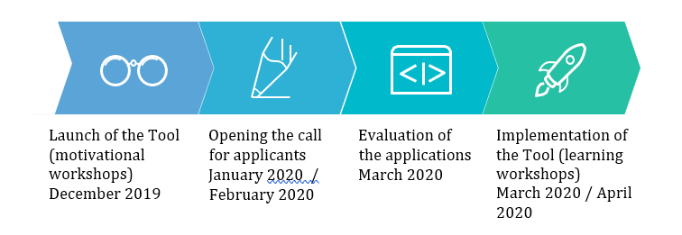

Process and application
Submissions are expected from students, young professionals, young entrepreneurs, individuals under the age of 35.
Submissions must be received no later than 28th February 2020, 23:59:00 CEST
All applications must be submitted using the F6S platform via link below:
www link will publication on 29.1.2020
No paper submissions will be considered.
Results of the evaluation phase will be communicated directly to applicants within 10 working days after the closure of submission.

Beneficiaries
Target group are Young Innovators - individuals under 35 years of age - with projects with specific industrial focus on innovative solutions addressing energy efficiency field that are still at the idea stage, but with no product, traction, or even a working prototype.

The aim of the Tool is to boost Young Innovators’ knowledge on business challenges in energy industry and to directed them towards their successful ventures.

Regional Partners in the Project
Germany, KIC InnoEnergy Germany GmbH
Bulgaria, Cleantech Bulgaria Foundation
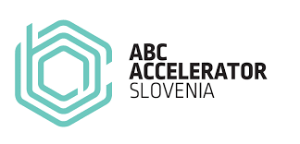
Slovakia, Civitta (Neulogy, a.s.)
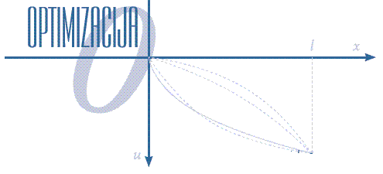
Slovenia, ABC Accelerator, d.o.o.
Croatia, Optimization
Czech Republic, E-KLASTR Czech Republic a.s.
Romania, Startup Transilvania Center
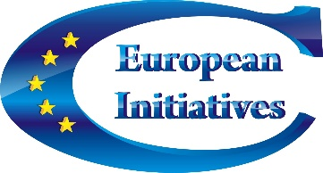
Serbia, SEE ICT
Ukraine, European Initiatives Center

Selection Criteria
The preliminary and evaluation phase of the projects will be carried out by Consortium Technical Committee and will be based on the following criteria:
Eligibility
- age factor (under the age of 35)
- no venture established beforehand for the idea in the program
- idea fits one or several of the following fields:
- Energy storage
- Smart and efficient buildings & cities
- Renewable energies
- Smart electric grid
- Energy efficiency
- Energy for circular economy
- Energy for transport & mobility
- Other fields, related to sustainability, energy efficiency and renewable energy.

Quality Criteria (scores)
- problem clearly identified
- potential for a successful company
- scientific background of individual
- potential for future investment in the idea/product
- idea compliant with national and/or EU regulations
- scalability of the product
- market need for the product / service
- growth strategy defined

Privacy Section
Annex A

Information on the processing of personal data

Within the meaning of Article 13 of EU Regulation 2016/679 (General Regulation on Data Protection – GDPR)

1. Purpose of processing
E-KLASTR Czech Republic a.s. as a project partner is processing your personal data in relation to calls, notices, invitations, applications, information requests, permissions, disclaimers and the like, related to specific projects. This data is processed pursuant to the consent you expressed within the meaning of Article 6(1a) GDPR.
In compliance with the obligations envisaged under the GDPR and Legislative Decree no. 196 of 30 June 2003 and amendments and additions ("Personal Data Protection Code", hereinafter: the "Code"), you are hereby informed that (Maja Jerala, maja@abc-accelerator.com)) as Controller, will subject the user/visitor's freely communicated personal data to processing in compliance with the standards in force.
In particular, processing will be based on principles of correctness, permissibility and transparency as foreseen by Article 11 of Legislative Decree No. 196/2003: no excess data will not be collected or recorded beyond that which is necessary for the purposes referred to above, nor retained for longer than necessary for the purposes for which they were collected.

2. Type of data processed
The optional sending of questions, requests, expressions of interest, applications, curriculum vitae and the like to E-KLASTR Czech Republic a.s. may lead, by way of example, to the processing of the following types of data of the data subject: demographic and identification data, contact data, bank details, information on the employment, business or professional activities of the data subject, as well as other any personal data requested by the Call, Notice, Invitation or similar procedure of E-KLASTR Czech Republic a.s..

3. Processing methods
The processing of the data may be carried out in either a non-automated manner or with the aid of electronic, informatics and telematics tools, during the time period which is strictly necessary to achieve the purposes for which they were collected.

Aside from communications required by law, the collected data will be communicated to third parties only if this is necessary for the fulfilment of the requests or for carrying out the purposes referred to in Paragraph 1. The data will not be disclosed, unless in an anonymous and aggregated form, for statistical purposes and for the promotion of E-KLASTR Czech Republic a.s. activities.
Only with the express consent of the data subject may the contact details of the applicant be used by E-KLASTR Czech Republic a.s. to send communications concerning its initiatives, such as conferences, events and training courses which are considered to be of interest to the applicant.
In carrying out the processing, all technical, IT, organisational, logistic and procedural-security measures will be taken to ensure an adequate level of data protection. The security measures mentioned above will ensure the data can be accessed only by those individuals responsible for ABC Accelerator's processing pursuant to Point 4.

4. Optional provision of data
The data subject is free to provide his/her personal data.
If not provided, this may only result in it being impossible to obtain what is requested.

5. Controller and categories of processors and those tasked with the processing
The controller is E-KLASTR Czech Republic a.s. based in nám. Kinských 6, Praha 5 150 00. The personal data will be processed by employees, colleagues and/or consultants appointed by the controller, operating as tasked or as processors, by specific appointment of the controller, and subject to specific contractual obligations.
The processor is Lenka Cilova The processor may be contacted via email on the following address: contactme@powerhub.cz

6. Rights of data subjects
You may at any time exercise your rights under Articles 12 et seq GDPR, by contacting the processor. The data subject is entitled to ask the controller for access to his/her personal data, and to correct or erase them or to have their processing restricted, or to object to processing (Articles15 et seq GDPR).

